ROB 101

Computational Linear Algebra

Homework 2

1. Read Chapters 2 and 3 of our ROB 101 Booklet, Notes for Computational Linear Algebra. Based on your

reading of the document, summarize in your own words:

(a) Choose a chapter and summarize its purpose;

(b) Two things you found the most challenging. If it was all straightforward for you, then summarize the two things you

found the most interesting.

Solution:

Purpose: The basic purpose of chapter 2 (Vectors, Matrices and Determinants) is introduction of building blocks of linear algebra i.e. Vectors, Matrices and Determinants and the conceptualization of linear systems in matrix vector format. The chapter teaches us how to write linear equations in the form of matrix and vector and how determinant of matrix can be useful in determining if a unique solution exists to system of equations or not.

Two things that I found interesting in this chapter are:

1. How we focus on applicative part of determinant and use it even though we don't understand it.
2. How we beautifully transform equations into a format understandable and computationally efficient using Ax = b form

2. A system of linear equations with three unknowns

4x1 = 8

2x1 -10x2= -2

x1 + 2x2 - x3= 4

(a) Solve the system of equations using forward substitution. Show all the steps when determining your solution.

(b) Write the system in the form Ax = b, where you clearly identify A, x, and b

Solution:

4x1 = 8 => x1 = 8/4 = 2

2x1 – 10x2 = -2 => 10x2 = -2 –2x1 => x2 = (-2 –2x1)/-10 => x2 = (-2 –4)/-10 = 0.6

x1+ 2x2 –x3 = 4 => -x3 => 4 – 2x2 –x1 => x3 = -(4 –2x2 –x1) = -(4 –1.2 -2) = -0.8

x1, x2, x3 = 2, 0.6, -0.8

A = [ 1 0 0; 2 –10 0; 1 2 –1]

b = [8; -2; 4]

x = [2; 0.6; -0.8]

3. A system of linear equations with three unknowns

-2x1 + x2 = 11

x2 - x3 = 5

2x3 = -10

(a) Solve the system of equations using back substitution. Show all the steps when determining your solution.

(b) Write the system in the form Ax = b, where you clearly identify A, x, and b.

Solution:

2x3 = -10 => x3 = -10/2 => x3 = -5

x2 –x3 = 5 => x2 = (5 + x3)/1 => x2 = (5 – 5)1 => x2 = 0

-2x1 + x2 = 11 => x1 = (11 – x2)/-2 => x1 = (11 – 0)/-2 => x1 = -5.5

x1, x2, x3 = -5.5, 0, -5

A = [ -2 1 0; 0 1 -1; 0 0 2]

b = [11; 5; -10]

x = [-5.5; 0; -5]

4. Determine the diagonal of each of the following matrices

(a) A1 =

[1 2

3 4]

(b) A2 =

[1 2 -4

3 -2 14

e 20.5 pie]

(c) A3 =

[1 2 2 1

11 12 14 13

e 20.5 pie (pie)0.5]

Solution:

1. diag(A1) = [1 2]
2. diag(A2) = [1 –2 pie]
3. Matrix is of form 3 \* 4. Diagonals only exist for square matrices. So A3 does not have a diagonal.

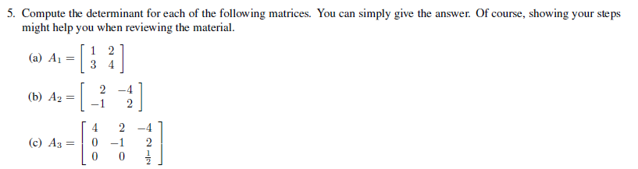

Solution:

1. Det(A1) = ad – bc = 1\*4 – 2\*3 = 4 – 6 = -2
2. Det(A2) = ad – bc = 2\*2 - (-1)\*(-4) = 4 – 4 = 0
3. Lower Triangular Matrix

Det(A3) = 4\*-1\*(½) = -2

6. Julia programming skills:

(a) Turn in a list of Julia commands that you have used or learned so far in ROB 101. Your list does not need to be

exhaustive. Keeping an organized list of commands in a google doc will greatly help you to master the programming

part of the course.

(b) Are there any errors that you keep making over and over?

Solution:(a) Commands which are majorly used till now,

ones, I, zeros, for k = a:b:c, end, inv, det

And then we have basic operations and indexing to help us stay in the game.

(b) Course has been taught in a way that concepts are flowing naturally to me so not much trouble till now.

End of Assignment